Step 1 — AI Assistant
Ask an AI assistant:
What is an AI assistant? Explain it in 2 simple sentences.
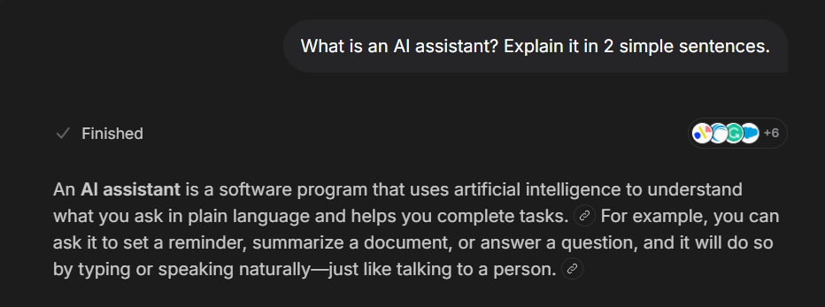
an ai Assistant helps you complete task , and achieve goals using Artificial intelligence using simple language
Step 2 — LLM
Ask an AI assistant:
What is an LLM? Explain it simply for a beginner.
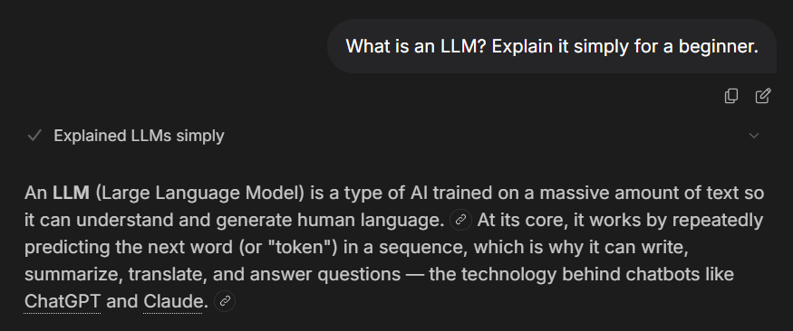
LLM , stands for large language model , its an ai that is trained on human resources like books and almost the entire web , using reddit or anything to fix problems and achieve the completion of a task
Step 3 — Hallucination
Ask an AI assistant a factual question about a topic of your choice.
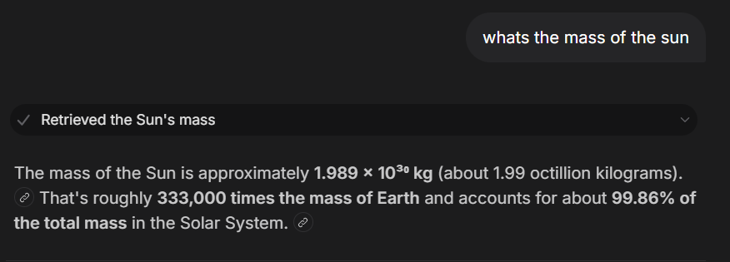
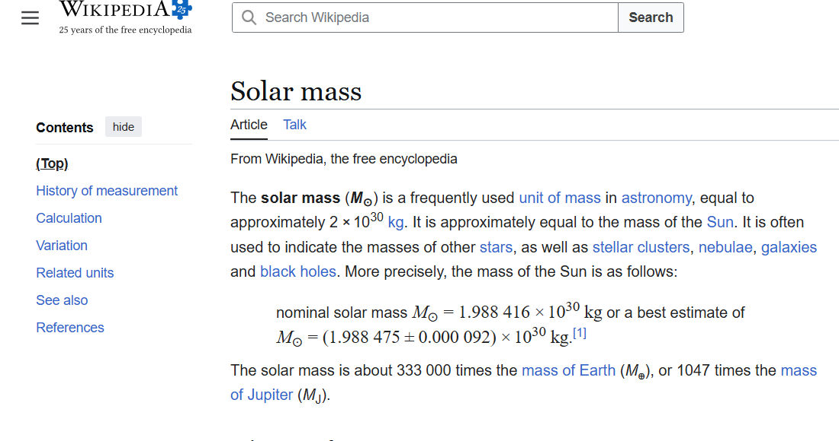
- Verify the answer using a reliable source.

The information is CORRECT! .

Step 4 — Create a Good Prompt
Create a prompt using:
Task + Context + Constraints + Output
Task : I want u to tell me if life is worth living
Context : im a 25 years old dude with lots of potential
Constraint : just say it is in under 3 words
Output : each word in a line and lots of happy emojis

Step 5 — Improve a Prompt
Start with this vague prompt:
Explain Python.
Ask the AI to improve it by making it more specific for a beginner student.
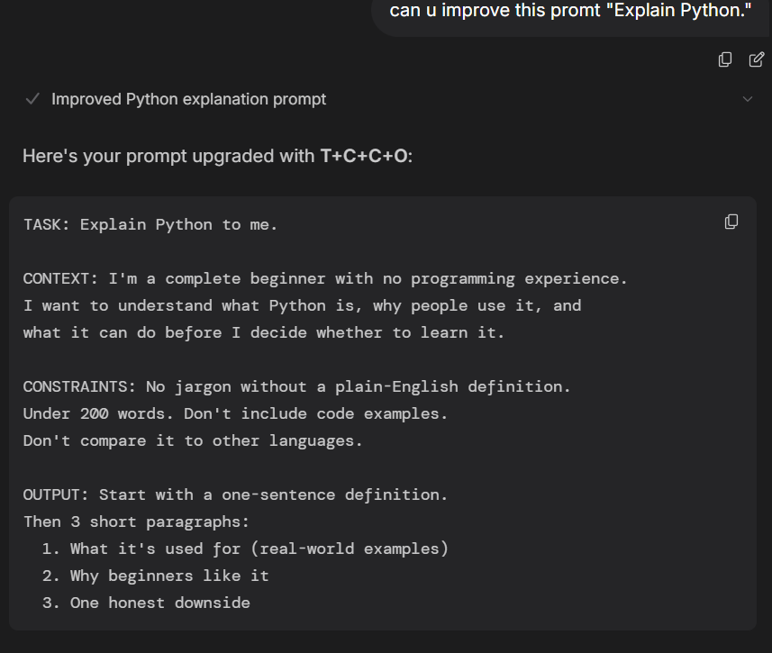

What was improved : the usage of Task + Context + Constraint + Output
Step 6 — Token & Usage Limits
Answer the following:
- What is a token?
  - A small chunk of a word , like an alphabet
- What is a context window?
  - It’s the amount of tokens it can process in one request
- What is the difference between a token limit and a usage limit?
  - Usage limit : is the global limit you get on a particular model
  - Token Limit : is how much token can be used in output/input

